**GPIO – GAUGE - Switch**

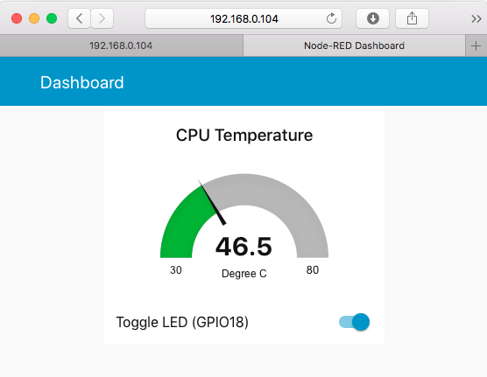

Tiene 2,

* El gauge para leer temperature,
* Switch el Toogle LED para encender, apagar LED que es un

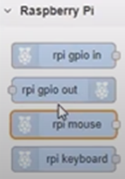

Drag a “**gauge**” dashboard node to the new flow

Double click on the gauge and click on the ***Edit*** (the little ***Pen***icon) to “Add new ui_group”, and give it a name (e.g. “MyDashboard”), also name the dashboard screen as “Dashboard”, this will eventually displayed on the screen as page title;

|  |  |
| --- | --- |
| gauge configuration | Set the Units as Degree C.  Set range, minimum 30, maximum 80 |

Drag an “**inject**” node and an “**exec**” node into the flow, configure them and wire them together

Drag a “**rpi gpio**” output node and wire together with our new “**switch**” node.

The “**exec**” node return a string like temp:41.5'C as msg.payload.

However the “**gauge**” is expecting a msg.value to be used as the temperature display for the gauge, not a string. With a “**function**” node, the “**function**” allows us to write a JavaScript function to parse the string and return the temperature data as msg.value for the gauge to consume.

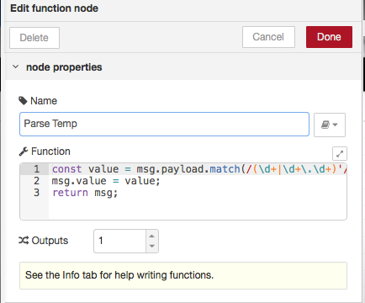

**The parse temp function in Javascript**

const value = msg.payload.match(/(\d+|\d+\.\d+)'/)[1];

msg.value = value;

return msg;

Now we can insert the “**function**” node between the “**wire**” node and the “**gauge**” node and wire them up.

**SWITCH**

Drag a “**switch**” dashboard node to the flow and configure the UI_group to be same as the UI_group used by the gauge.

The “**switch**” node will replaced the two “**inject**” nodes that we used to control the GPIO because the “**switch**” node can toggle between two statuses.

**TEST**

Point your browser to http://192.168.xxx.xxx:1880/ui, you should be able to see the Gauge and Toggle switch grouped within the same UI group.

Click on the switch will toggle the LED on and off.